**An Internship Report Presented to**

**The Faculty of the Department of Public Relations**

**of The London School of Public Relations - Jakarta**

**Internship at**

**PT. Bintang Anugrah Surya Semesta (BASS)**

**Training Center & Consultant**

Submitted By :

Name : Daffa Muhammad Ardian

NIM : 17110210324

Major : Public Relations

Class : PR 21 - 4C

In Partial Fullfillment of the Requirements for the

Bachelor Degree in Communication Studies



**Jakarta, Indonesia**

**January 2021**

**Part I - Introduction**

Students as the nation's next generation are required to be able to improve human resources, including improving intellectual abilities and student commitment through scientific disciplines as the application of knowledge received in College so that students can answer growing challenges.

In an expanding capable current of competition, there will need to be a planned, systematic, and applied activity to train and educate students to become a qualified youthful intellectual an responsive to the issue that emerge within the midst of society’s life and be able to work out the solutions.

In realizing and achieving this goal, this internship will neglect any of the appropriate frameworks for teaching students in the field. Apprenticeship is an outdoor exercise over a period of time to form students to better understand their field of thought. This internship combines several exercises, namely, question and answer exercises, student exemption, internship performance, apprenticeship reports, report collection courses.

On the execution of this apprentice, students are required to combine the learning acquired in the college with the real action in the field that has been adapted to the specific courses of communication and broadcasting in favor of increasing student knowledge of communications and broadcasting, which is so essential to augmenting their insight and experience that they are not solely theoretical, but flexible and realistic in the circumstance he faced an was able to mae decicions consistent with the working conditions and abilities.

With this apprentice, it is hoped that it will help to find solutions to problems in the world of mass communication, as this apprentice is a requirement for phase communication programs. In order to provide practical vocational and vocational adjustments in the work wolrd. It may implements a pattern of apprenticeship , expecting the graduates to have academic and professional abilities.

* **Purpose and Benefits**

As for the objectives that this apprenticeship would serve as followers:

1. The public education desired from this apprenticeship is to gain skill and experience, adjustments in attitudes and knowledge in the work world especially in the field of communication.
2. Special Purpose
3. Identifies a communication programmer from the apprenticeship pattern of expeceting the graduates world you implementies professional abilities.
4. Indentifies a communication programmer in order to provide vocational adjuments in the work world.
5. Identify the problem of Communication about the people’s increased knowledge and awareness efforts regarding Communication in the intern facility.
6. The public program have academic and professional activies expecting.

* **Guidance Needed**

In an exertion to learn around the execution of this apprenticeship, as a Student for the primary time within the world of work, I was greatly helped by the guidance that was received. Besides this, I also get guidance from other staff who really help me in completing my assignments.

1. **Statement Of Internship Location & Duration**

On September, 2020 , I did an internship at one of the Training Center & Consultant companies PT. Bintang Anugrah Surya Semesta (BASS). PT Bintang Anugrah Surya Semesta (BASS) is located in Bintaro Trade Centre, Blok C2 - No. 19, Jl. Jend. Sudirman, Pusat Kawasan Niaga, Bintaro Jaya Sektor VII, Pd. Jaya, Pd. Aren, South Tangerang, 15224. My Jobdesk as Public Relations with an internship for 3 months until Desember 2020.

**Part II – Background of the Company / Company Profile**

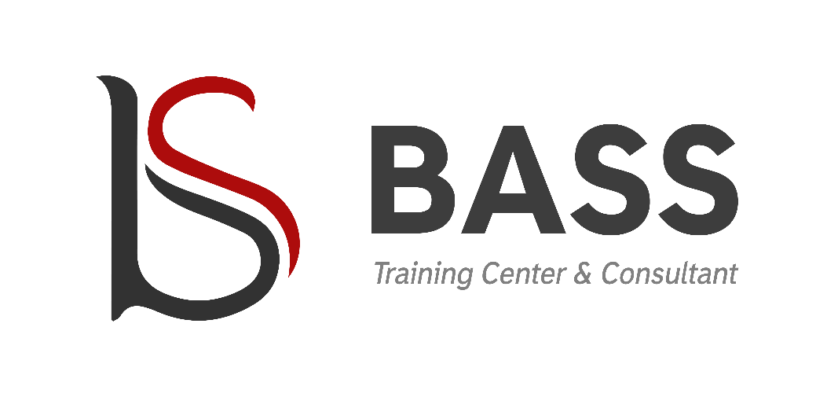

1. **ABOUT US**

PT Bintang Anugrah Surya Semesta (BASS) is a consultant company engaged in the ­eld of management services, education and training of Human Resources (HR) which is prepared professionally by prioritizing on quality and customer satisfaction.

PT BASS was established in 2016 as a manifestation within promote competency based training to human resources at Indonesia to support the needs of the industry with work produces a competent, professional, and highly competitive workforce.

We can also provide consulting services to businesses to help improve productivity and improve quality, health and safety and environmental standards through HR consulting services, ISO 9001: 2015, OHSAS 18001: 2007 and ISO 14001: 2015 as well as other consulting services.

The consultant and training services provided are prepared and provided by Experts and Practitioners who are highly experienced in their ­eld and recognized competence.

1. **VISION**

Being an institution that can increase organizational productivity, quality standards of management oriented to the environment, occupational safety and health and able to realize qualified human resources.

1. **MISSION**
2. Providing quality management, environmental and health management consulting services, safety and its training with consideration of key performance quality, cost & delivery.
3. Able to provide the best solution in improving company performance
4. Conducting competency-based education and training as needed industrial world of work.
5. Implement coordination of plans, programs and management of personnel in various sectors.

**OFFICE**

**BASS Training Center & Consultant**

**PT. Bintang Anugrah Surya Semesta**

Bintaro Trade Center Blok C2, No. 19 1st Floor

Jl. Jend. Sudirman, Pusat Kawasan Niaga,

Bintaro Jaya Sektor VII, Pd. Jaya, Pd. Aren

Tangerang Selatan 15224

Tlp : 021 222 15016

Hp : 0821 1279 8728

Email : [adm.bintanganugrah@gmail.com](mailto:adm.bintanganugrah@gmail.com)

Web : [www.bassconsultant.com](http://www.bassconsultant.com)

**Part III – Assessment of the Internship**

1. **Supervision**

Supervision carried out by PT. Bintang Anugrah Surya Semesta (BASS), namely by using KPI (Key Performance Indicator) to measure and evaluate organizational performance in order to achieve organizational targets. Meanwhile, the assistance that the company gave me was by providing guidance or training every week regarding the Jobdesk that I was working on and even reviewing the products owned by the company specifically.

1. **Activities**

|  |  |  |
| --- | --- | --- |
| **Number** | **Activity plan** | **Activity time** |
| 1 | Introduction and adjustment to the work environment | 21 – 23 September 2020 |
| 2 | Prepare a Proposal for PT. Bintang Anugrah Surya Semesta | 28 – 29 September 2020 |
| 3 | Revised Proposal of PT. Bintang Anugrah Surya Semesta | 30 September 2020 |
| 4 | Compiling the Organizational Structure of PT. Bintang Anugrah Surya Semesta | 1 Oktober 2020 |
| 5 | Revision of the organizational structure of PT. Bintang Anugrah Surya Semesta | 2 Oktober 2020 |
| 6 | Creating a Brochure of PT. Bintang Anugrah Surya Semesta | 5 – 9 Oktober 2020 |
| 4 | Creating a Flyer for PT. Bintang Anugrah Surya Semesta | 12 – 23 Oktober 2020 |
| 5 | Making a Proposal for PT. Bintang Anugrah Surya Semesta | 26 – 28 Oktober 2020 |
| 6 | Making a Training Schedule and Certification Assessment for PT. Bintang Anugrah Surya Semesta (BASS) | 1 November 2020 |
| 7 | Creating Training Invoice | 10 – 20 November 2020 |
| 8 | Compiling Attendance List for Certification Training and Assessment | 25 November 2020 |
| 9 | Compile a Database | 1 – 10 Desember 2020 |
| 10 | Creating a Training Certificate | 1. – 20 Desember 2020 |

1. **Obstacles**

One of the obstacles that has become my problem in carrying out the apprenticeship here is that it is a little difficult for me to understand the workflow of this company, besides because I have no work experience, this company also has the concept of working in multitasking so it needs full adaptation and concentration.

1. **Evaluation**

I feel satisfied carrying out my apprenticeship at PT. Bintang Anugrah Surya Semesta (BASS), because I can absorb a lot of knowledge such as understanding workflow processes, time management, working in multitasking, learning how to build good relationships with clients, learning how to market products / services well, compiling databases, and go directly to handling clients such as Follow Up to negotiating with clients. Besides getting new knowledge, the most important thing is that I get work experience, by doing apprenticeship here, I get it all.

**Part IV – Conclusion and Recommendation**

1. [**https://drive.google.com/file/d/1o6aJQkyxsl9Rczp5rqvvWGwAJ-W1iIer/view?usp=sharing**](https://drive.google.com/file/d/1o6aJQkyxsl9Rczp5rqvvWGwAJ-W1iIer/view?usp=sharing)
2. **Samples of work output with supervisor’s signature**

[**https://drive.google.com/file/d/17aiYvXyKV6ugRgU6FWJSkGDk9t_M97CJ/view?usp=sharing**](https://drive.google.com/file/d/17aiYvXyKV6ugRgU6FWJSkGDk9t_M97CJ/view?usp=sharing)

1. **Intern’s photo in the workplace**

